Project Design Phase-II

Data Flow Diagram & User Stories

|  |  |  |  |
| --- | --- | --- | --- |
|  | Date | 18 October 2022 |  |
| Team ID | PNT2022TMID27489 |
| Project Name | Project – Web phishing detection |
| Maximum Marks | 4 Marks |

# Data Flow Diagrams:

A Data Flow Diagram (DFD) is a traditional visual representation of the information flows within a system. A neat and clear DFD can depict the right amount of the system requirement graphically. It shows how data enters and leaves the system, what changes the information, and where data is stored.

# DFD level 0

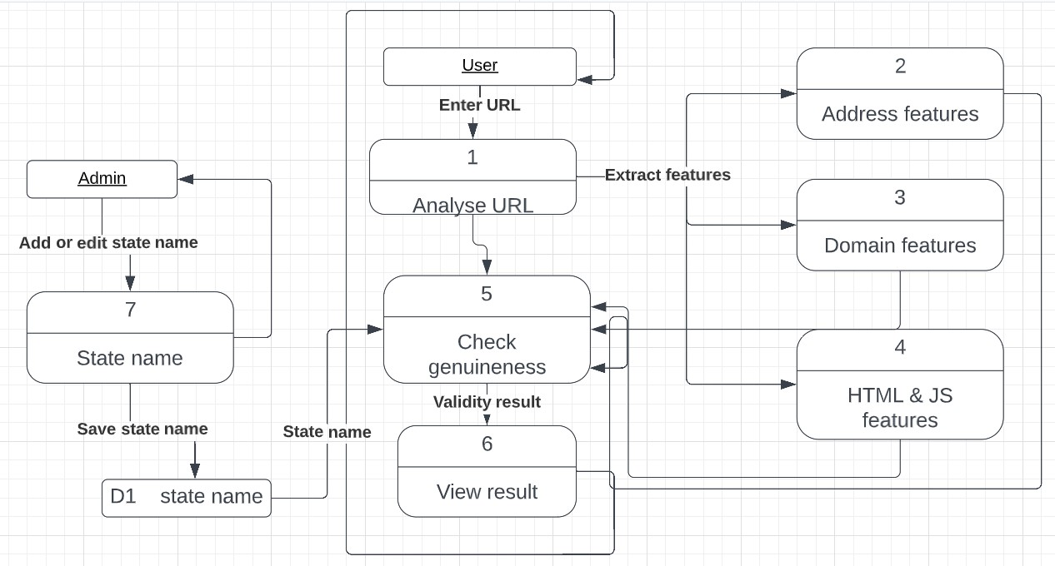

**User Stories:**

|  |  |  |  |  |  |  |
| --- | --- | --- | --- | --- | --- | --- |
| **User Type** | **Functional Requirement**  **(Epic)** | **User Story Number** | **User Story / Task** | **Acceptance criteria** | **Priority** | **Release** |
| Customer (Web user) | Login | USN-1 | As a user, I can navigate into the website | I can access the page | High | Sprint-1 |
|  | Dashboard | USN-2 | As a user, I will paste the URL that needs to be checked if it’s a phishing website or not | I can paste the URL in the text box | High | Sprint-1 |
|  |  | USN-3 | As a user, I can see the output | I can see if it’s a safe site | High | Sprint-1 |
| Administrator |  | USN-4 | If a new URL is found, I can add the new state into the database | I can add the new URL | Medium | Sprint-2 |